Change detection locations

Jamie’s YouTube

1. Number of subscribers removed.

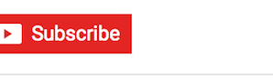

1. Channel 4 logo in thumbnail on Jamie’s face in the bottom right quarter.

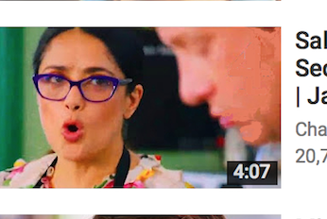

1. Humans thumbnail inserted.

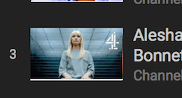

1. Likes and dislike thumbs swapped over.
2. Line of text removed at the bottom middle of the screen.

Spies YouTube

1. Number of views changed.
2. End of the title removed.

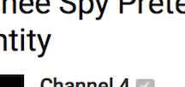

1. Removed GB from the end of YouTube logo.

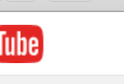

1. Info sign removed from the top right of the video window.

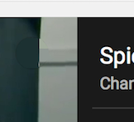

1. Bus removed from the banner in the video in the top right.

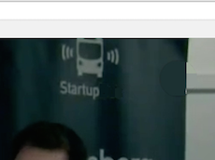

Made In Chelsea All4

1. Clock removed next to days remaining.

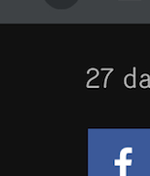

1. Changed the minutes that have occurred.

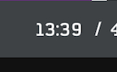

1. Removed the purple vent on the right sidebar, in the middle.



1. Series 13 has become series 16, top left.

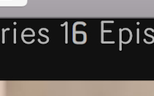

1. Watch next has changed colour

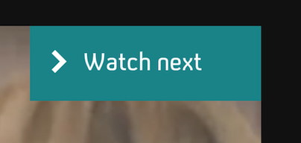

Humans All4

1. Top bar on screen moved to the right.

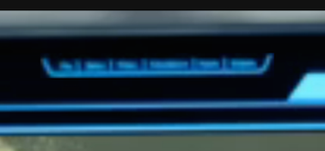

1. Social media logos swapped positions.

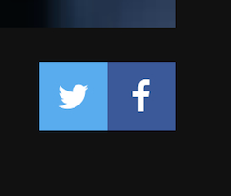

1. Parental control lock removed.

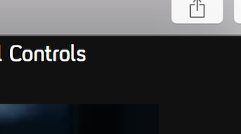

1. Side bar element removed.

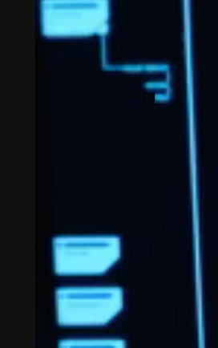

1. Programme description changed.

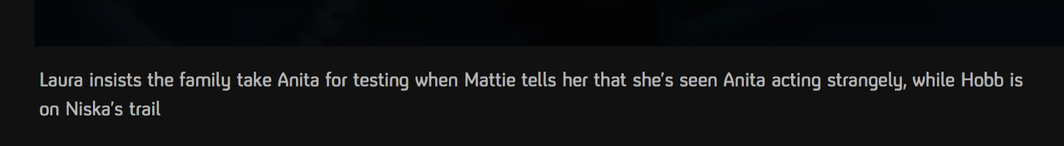

Practice All4

1. Last part of title removed.

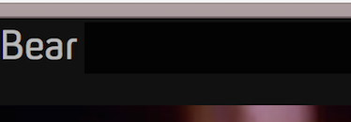

1. First I removed from the on screen title.

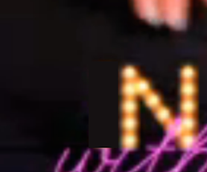

1. Double twitter logo.

